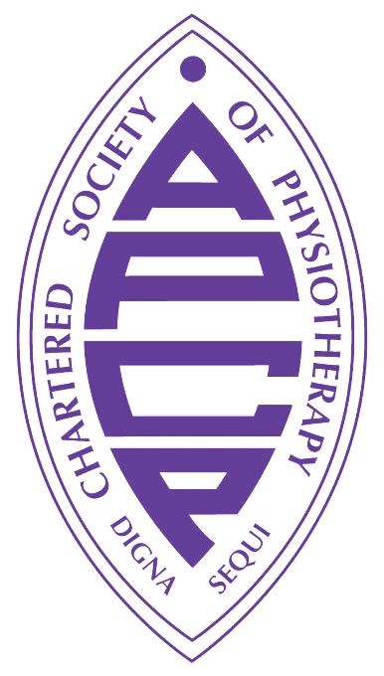
APCP Neonatal AHP 9th Annual Conference
Tackling Health Inequalities: an embedded approach.
Abstract Submission
Holiday Inn, Kensington High Street, London – 14th November 2024

Please ensure that you read this form in full before completing the abstract submission form. Any abstracts that do not adhere to these guidelines will not be accepted.
The neonatal conference is including both paper (podium) presentations and poster presentations. Submitting an abstract and presenting at the study day is an opportunity to share your work and learning whilst enhancing your continuing professional development. We welcome submissions from all areas of neonatal AHP practice.
If you are thinking of submitting an abstract, please read through this guidance to support you with the application.
Section A: Personal Details

Authors
Please give the first name, surname and institution name (place of work or location where work was carried out) of main authors associated with abstract; omit degrees, titles or appointments. Please list the primary author and contact first.

Contact Details
Please provide a work or home email address where any correspondence can be sent prior to and following the conference.
Section B: Abstract (Please indicate session 1, 2 or both you are applying for).

Title
The title of your abstract/s should be succinct yet accurately describe its main content. Do not use abbreviations. Use sentence case (i.e. the first letter of the sentence is capitalised and the rest in lower case, apart from proper nouns and acronyms).

Presentation Format
There is a choice of presentation formats. Please indicate your choice on your submission/s. The Neonatal Therapy Study Day Committee will make the final decision on the presentation format.
15-minute Paper Presentation
Paper presentations allow you to present details of projects or research you have undertaken. You will have 15 minutes to introduce your work including time for questions. The presentations will manage closely for time length, so please ensure that you focus on presenting the most important aspects of your work and the implications for neonatal therapy practice, while also allowing sufficient time for questions during the 15-minute presentation.

Poster Presentation
Posters provide an opportunity to present an overview of your project and will be on display in the poster viewing area throughout the study day. Specific printing guidelines will need to be followed. It is important to remember to make your presentation appropriate for dissemination in a visual format, and so may include text, graphs/tables and pictures.

Abstract
The main body of abstract must be no longer than 250 words and include the following elements:
- Aim
- Background
- Methods
- Results/Findings
- Conclusion
Additional information

Number of abstracts per author
There is no limit to the number of abstracts that can be submitted by any individual or organisation. The committee reserves the right to limit the number of accepted abstracts from any one source.
Authors must spell check their submission and adhere strictly to the word count. Submissions which exceed the word count will not be reviewed.
Submission Due Date
All Abstract Submissions must be received by:
12noon on the 2nd of September 2024 and successful submissions will be announced on the 1st of October
Please e-mail your completed form to ally@apcp.org.uk
(NB: If you are successful with your application, please ensure you have secured your place to attend via the APCP website, thank you).

Further questions
If you have any questions, please contact us at: ally@apcp.org.uk

