From the beginning of life, movement is important for everyone.

Find out more about how you can support your child’s movement and physical activity by scanning the QR link below or going to [www.apcp.csp.org.uk](http://www.apcp.csp.org.uk).

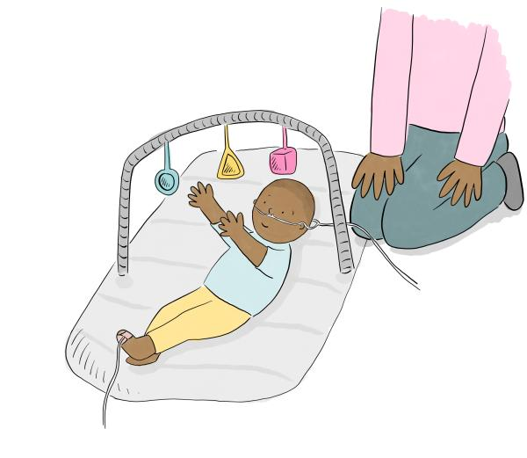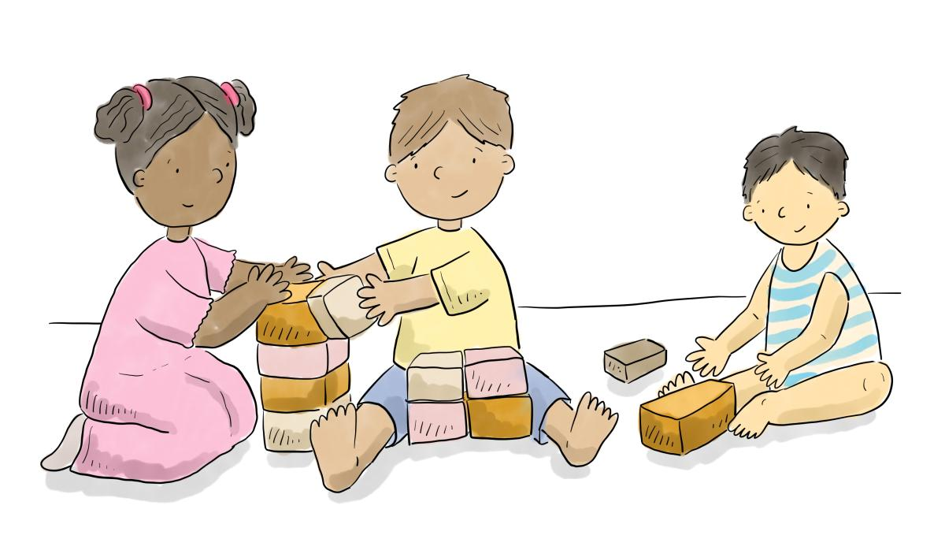

The Association of Paediatric Chartered Physiotherapists are a recognized Professional Network of the Chartered Society of Physiotherapy (CSP). We are always looking to improve our APCP resources. If you have any recommendations on how to improve this resource please contact us via [office@apcp.org.uk](mailto:office@apcp.org.uk)

*The illustrations from this project have been created by Hannah Littler-Smith and The Great North Children’s Hospital Foundation, part of the Newcastle Hospitals Charity.*