Starting2Move
Movement for all, from the very beginning of life

We know movement and physical activity is important for all of us. We know how we move influences our overall health and wellbeing. Our early movement experiences, and our movement development, is inextricably linked with our other developmental domains. In the first years of life, when we are on a steep learning trajectory, our movement experiences have a huge influence upon our physical, cognitive, language and socio-emotional development.

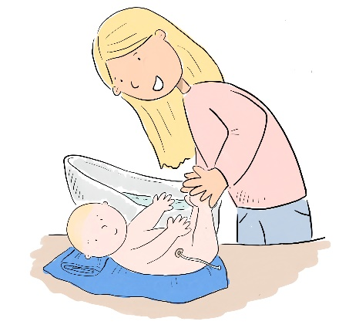
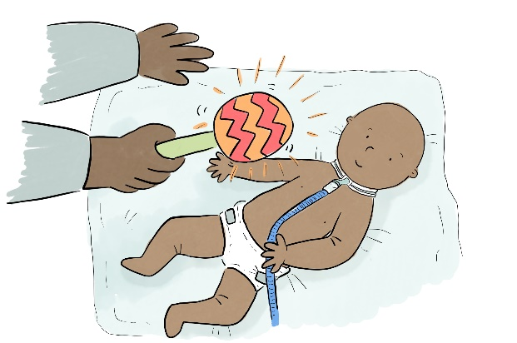

Importantly, we know that some of us experience greater barriers to positive movement experiences than others. None of us choose our birth characteristics or the situations that we’re born into. The Association of Paediatric Chartered Physiotherapists (APCP) are committed to supporting healthy movement for all, from the very beginning of life. APCP hold a wealth of knowledge to contribute to improving population health outcomes and reducing health inequalities - we need to get better at developing, sharing, and acting on this information.
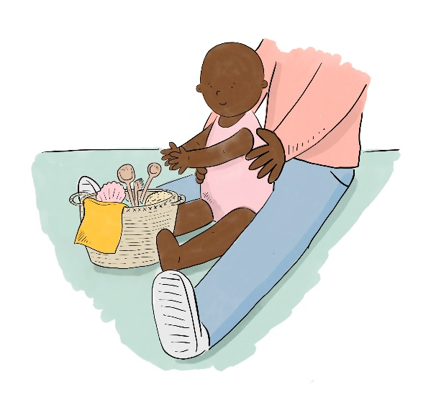
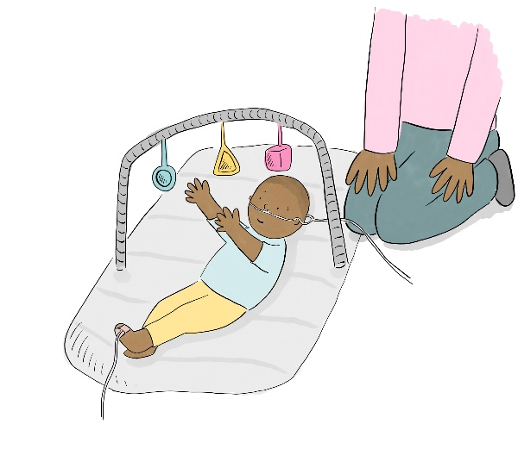

The Chartered Society of Physiotherapy (CSP) have already produced a number of brilliant campaigns to support movement and physical activity for adults. APCP wanted to replicate this to share important messages about movement for babies, children and young people. We especially want to prioritise support for those of our population that face additional barriers and are often underserved. APCP are committed to promoting a society of inclusion, where everyone, from the very beginning of life, can enjoy the benefits of movement.
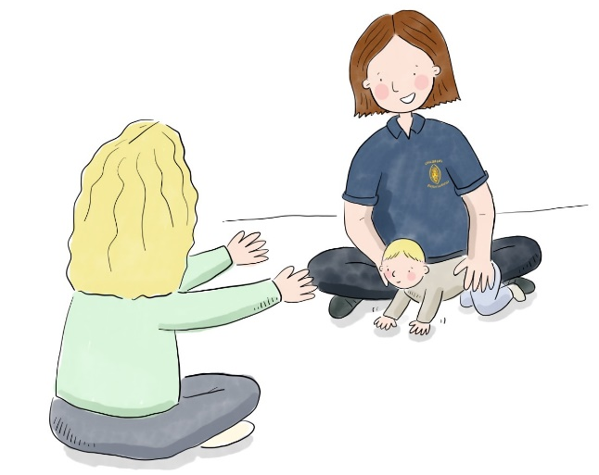
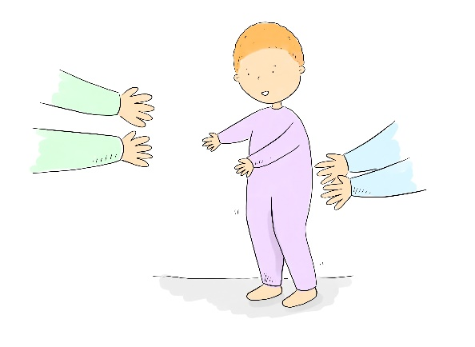

APCP submitted a funding application for a professional network award from the Chartered Society of Physiotherapy. The majority of that money was for stakeholder engagement events, prioritising learning from and supporting typically underserved communities. APCP were delighted to hear this funding bid was successful.
We’d planned various engagement events around the country to listen, learn and amplify the voices of children and their families, and others trying to support them. The project was planned to be completed by Summer 2020. However, in March 2020, as you can guess…everything was overturned by the arrival of the COVID-19 pandemic. We all faced unprecedented challenges. Many paediatric physiotherapists, including myself as the project lead, were redeployed into entirely different clinical areas for prolonged periods. I was redeployed into adult intensive care for 6 months.
Find out more about paediatric physiotherapy in response to the COVID-19 Pandemic here: https://apcp.csp.org.uk/sites/default/files/journal/2020-11/APCP%20Journal%20V11%20N2_0.pdf

When some sense of normality returned, picking up the pieces to progress this project was not easy. Due to the reduced availability of resources, the process for finishing the project looked very different. However, not all was lost.
With support from many different colleagues, we reviewed our project strategy and transformed what we had into generating a resource that would be of value to the public.
We have created a space that provides key early years movement support in the format of;
- A brief summary of why early years movement is important
- A variety of practical tips for early years movement
- Information on movement concerns
- An early years’ movement blog
- Resources for professionals
- Signposting to other resources that support early years

We owe huge credit to Hannah Littler-Smith (https://www.thingsiliketodraw.com) the artist who helped us to bring our messages to life. Furthermore, we are incredibly grateful to Penny Walsh (Paediatric Physiotherapist), Linsday Carr (Paediatric Occupational Therapists) and the Great North Children’s Hospital Foundation who shared their Don't Delay the Play Project with us, contributing an initial bundle of illustrations. Find out more out the Don’t Delay the Play project here: https://www.newcastle-hospitals.nhs.uk/services/dont-delay-the-play/)
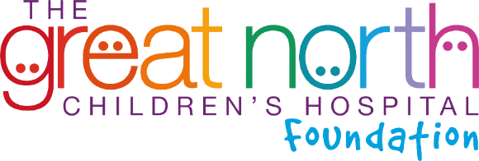

Moving Towards a Fairer Future
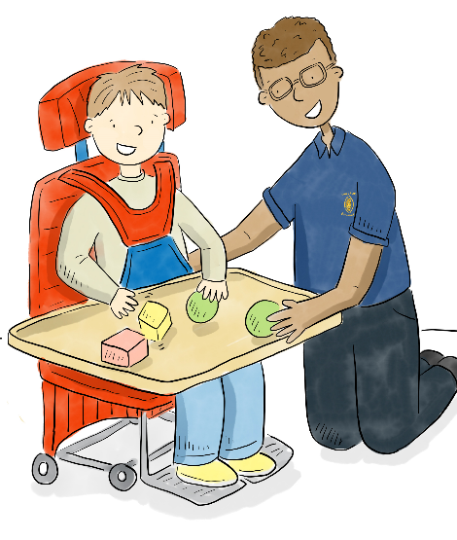
Paediatric physiotherapists use their expertise in movement to promote healthy development, and healthy lifestyles, for children and young people from birth to 19 years. We want to continue to build upon the Starting2Move project to transform our APCP information for all ages into this new format that we’ve started for the early years age group.
Please see the following Moving Towards a Fairer Future blog post for more details.
To continue to act upon our ideas to advance movement support for all of the paediatric population we serve, we need to secure more resources and partnerships. If you have resources to share, or would like to partner with us in our efforts, please do get in touch via office@apcp.org.uk
Thank you,
Jemma Bell
APCP Public Relations Officer
January 2023

