

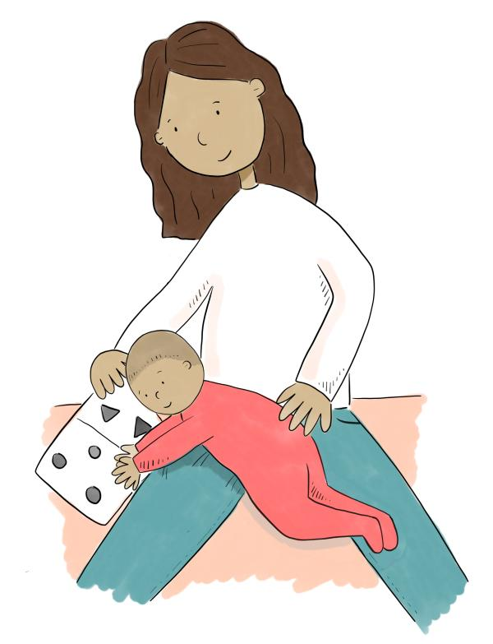

Today’s Date is:

and I am… weeks/ Month old

A little bit about me…

and a little guide to help me move

Today I saw: (Professional’s name)

Some of my favourite things I enjoy about movement are:

Here’s some things I need help with at the moment:

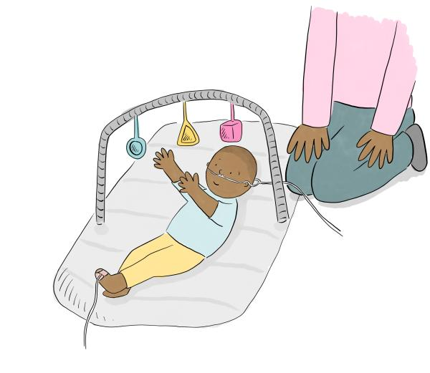

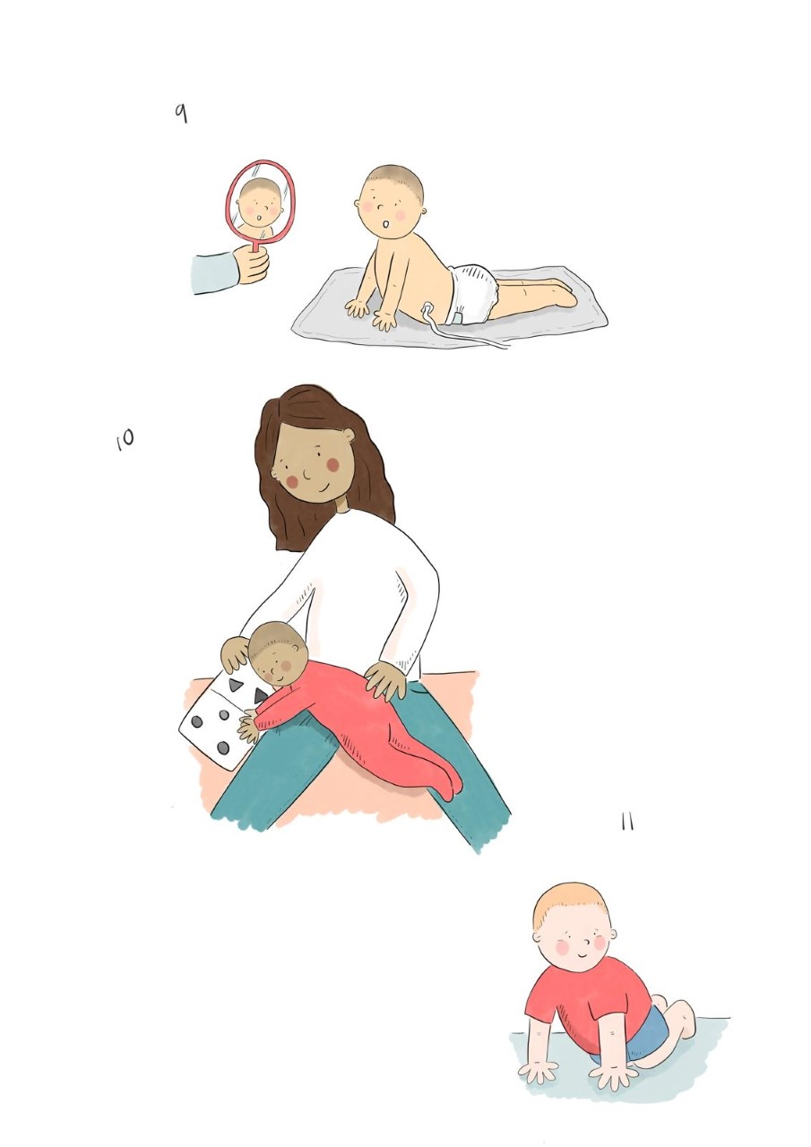

Here’s some ways you can help me:

You can find more information on how to help my movement here:

(Links to other resources and organisations)

The Association of Paediatric Chartered Physiotherapists are a recognized Professional Network of the Chartered Society of Physiotherapy (CSP).

You can find more information about us on our website: [www.apcp.csp.org.uk](http://www.apcp.csp.org.uk).

We are always looking to improve our APCP resources. If you have any recommendations on how to improve this resource please contact us via [office@apcp.org.uk](mailto:office@apcp.org.uk)