Moving Towards a Fairer Future
Moving forwards from the Starting2Move project
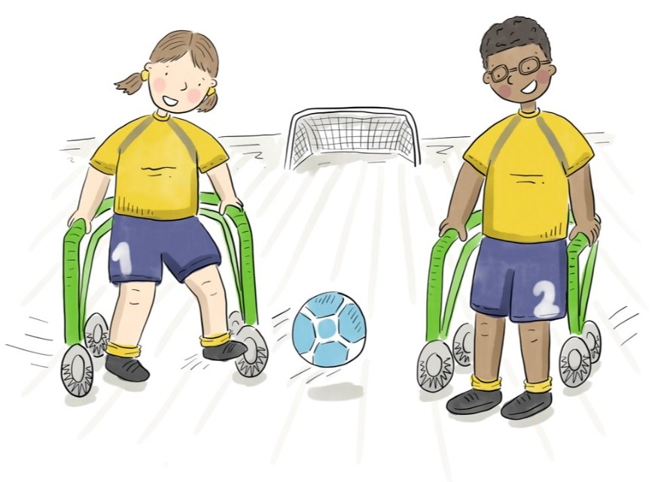

Paediatric physiotherapists use their expertise in movement to promote healthy development, and healthy lifestyles, for children and young people from birth to 19 years. We want to continue to build upon the Starting2Move project to transform our APCP information for all ages into this new format that we’ve started for the early years age group.
In May 2022 I spoke on behalf of APCP at the Chartered Society of Physiotherapy (CSP)’s Annual Representatives Conference. That short speech is included here:
“We all know that our early life, childhood and adolescent experiences provide the foundations for who we grow up to be - shaping our behaviour and establishing habits for the future.
In these critical stages of life, we all rely on the support of others to protect us and to help guide our development. We know that healthy investments in our early life helps us to establish trajectories for positive health behaviours and favourable health outcomes.
At a population level, we know that investments in child health support leads to better population health outcomes. Importantly, investments in child health support also offers us a prime opportunity to tackle population health inequalities.
This information has never been more important than now. The COVID-19 pandemic has had a huge impact upon our next generation, especially upon some of our most vulnerable children in society. And all of this occurred at a time when a substantial proportion of the paediatric workforce was redeployed.
Yet, we have a strong and growing paediatric physiotherapy workforce who are dedicated to protecting and supporting our next generation.
Over the past few years, with thanks to professional network funding from the CSP, the APCP have undertaken an early years movement project called Starting2Move – which primary focus is supporting movement for all within the first two years of life.
However, to move forwards, and to actively represent the breadth of the paediatric population that we serve the paediatric physiotherapy workforce need further representation, resources and leadership from the CSP.
We urge the CSP to lead a paediatric specific campaign that shares the contribution of paediatric physiotherapy with our diverse stakeholders from across the health, social and education sectors. Through this campaign, the CSP will be contributing to improving population health outcomes and reducing health inequalities – from the very beginning of life”
Please help us, help these children.
Thank you.”
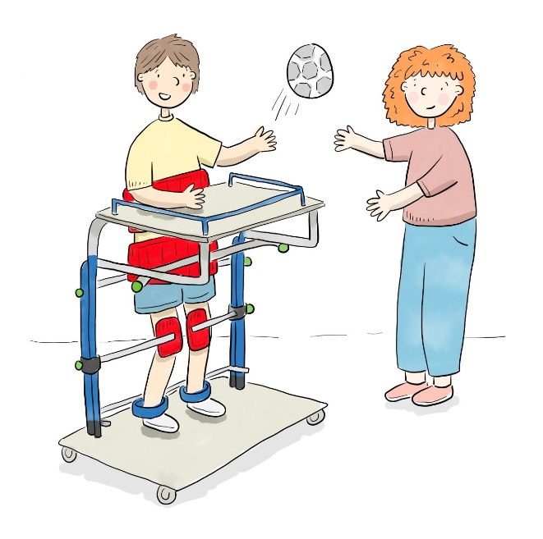
Moving Towards a Fairer Future is our vision for how we will move on from the foundations that the Starting2Move project has provided. A ‘fairer’ future is used here to encompass both equality and desirability, with the ambition to reduce avoidable health inequities and to promote desirable health outcomes for all.
However, this project is not yet funded. To continue to act upon our ideas to advance movement support for all of the paediatric population we serve, we need to secure more resources and partnerships. If you have resources to share, or would like to partner with us in our efforts, please do get in touch via office@apcp.org.uk
Thank you,
Jemma Bell
APCP Public Relations Officer
January 2023

