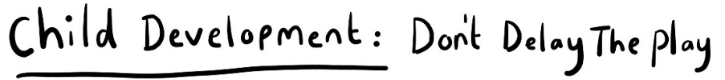

As AHP’s we know that reduced parental confidence in handling and playing with their child following medical intervention is a widely acknowledged challenge, especially when medical attachments such as lines, stoma bags, tracheostomies and others remain in situ.
We met as an MDT (including PT, OT and SaLT) with our aim to minimise the impact of prolonged hospital admission on the developmental progress of children between the ages of 0-24 months.
We wanted the project to:
- Empower parents and carers with the information and support to engage in developmental play with their child both within hospital and beyond.
- Educate and encourage staff to integrate developmental play within their daily interactions with these patients.
- To ensure resources produced mirror the diversity of the hospital population and the wide range of medical attachments required by the patients to provide a true representation of the patient experience.
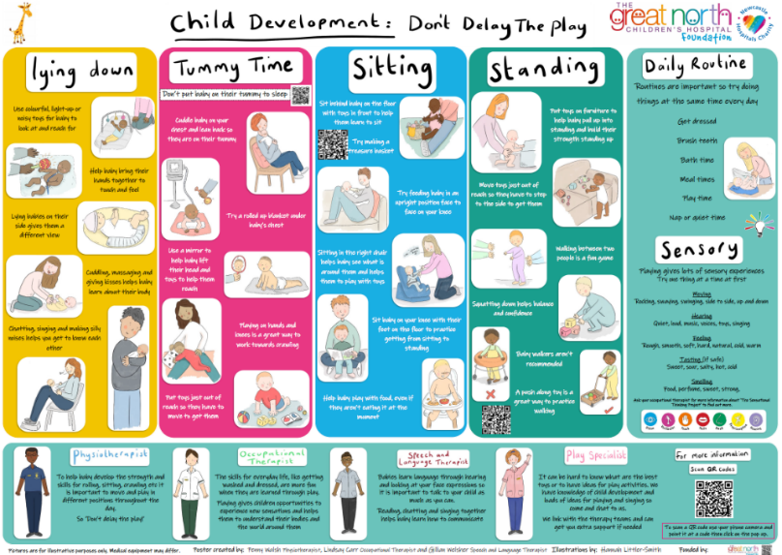
- To ensure the hospital environment enables parents, carers, and staff to optimise opportunities for developmental play as a standard of care.
Project:
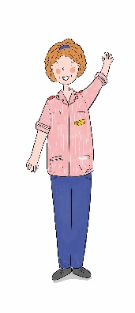
Within the Great North Children’s Hospital (GNCH) we started with informal chats with the families and staff involved in the care of this patient group. Then created this poster with bespoke illustrations demonstrating a range of developmental play activities and positions to encourage and support parents/ carers and staff with ideas they can follow. Using an MDT approach we tried to cover a broad range of physical, functional, sensory and communication based activities. QR codes link to an electronic version of the poster as well as additional resources. It’s important to note that the poster would not replace our specialist interventions for those children who need a more individualised approach, but would instead aim to compliment it and support the work of the ward based play specialists and nurses.
The posters are currently displayed on all the children’s wards across (GNCH) and Freeman as well as at a community outpatient clinic.

Working with Lynn Watson (communications manager at Newcastle Hospitals NHS Foundation Trust) we have also created some videos for the website to launch and support the poster’s message. The video’s includes the families who were involved in the initial stages of the poster development talking about the parent’s perspective and also explains how to navigate the poster.
We’ve had great feedback from families and staff and will look at a way of capturing some feedback more formally from parents once this is completely launched.
Future:
Further QI projects are planned to create a universal package of information, equipment and support for parents and staff within GNCH and Freeman under the umbrella of ‘Don’t delay the play’ that will enable them to access ‘developmental play’ as standard care.

