Therapy Doll- Make Your Own!
My therapy doll pattern, I have been sharing. Works great on zoom sessions. Doll is approx.. 85cm tall. Sew head and body as one leave gaps for limbs to attach at end. Sew limbs separately. Stuff head and body and limbs. Sew in limb joints after. Attach at hips and shoulders, sewing across hip and shoulder joint lines. Don’t overstuff. Hair and clothes optional.
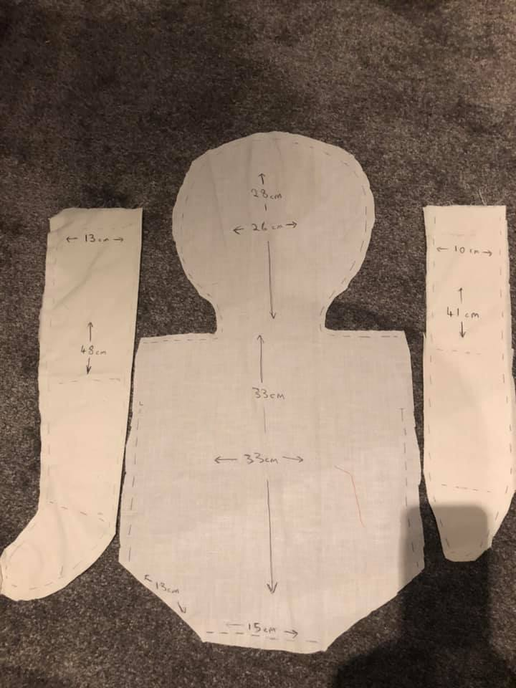

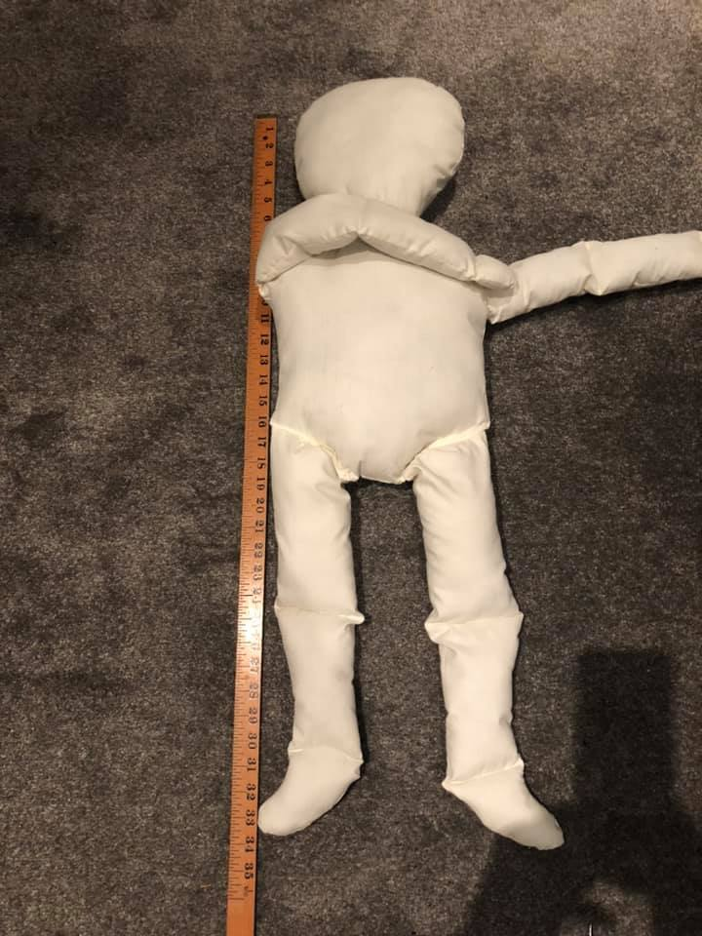

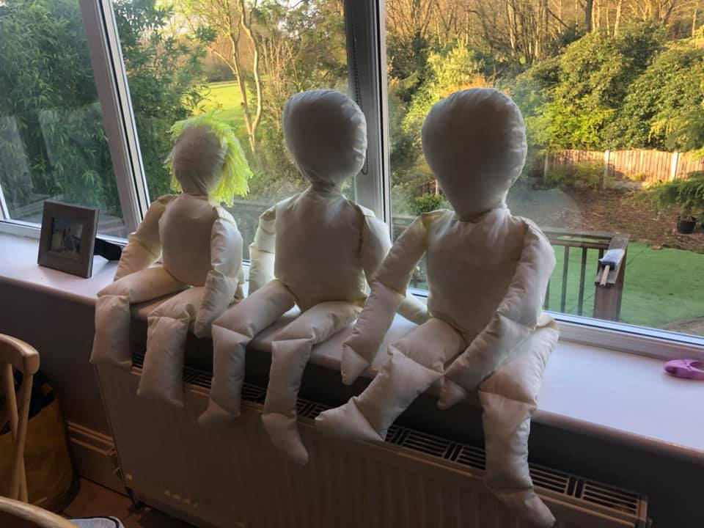
Aideen Frediani
APCP National Committee Member

